**Leman Nur Erkan**

**COGS 536 HW#5**

**1.a.** dependent var.s = The length of gazes (in sec) of a schematic face, concentric circles, a section of a newspaper , independent var.s / factor: = The length of gaze (in sec) of an infant at an unpatterned white circle.

H0= infants had little or no pattern vision during the early weeks or even months of their lives. // There is no difference btw the means of gazes of patterns and the mean of the gazes of white circle

HA= infants had pattern vision during the early weeks or even months of their lives // There is difference btw at least the one of the means of gazes of patterns and the mean of the gazes of white circle

**b.** one way, repeated measures anova.

One-way analysis of variance is used to compare the means of two or more independent groups under one factor. Since the patterns observed here are independent of each other, this is used. This repeated measure is anova, as these observations are obtained by measuring the same dependent variable on the same subjects under different conditions.

**c**.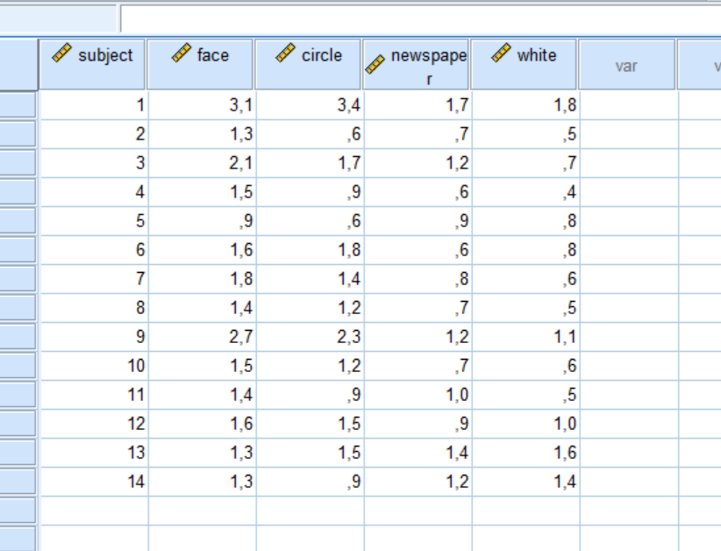

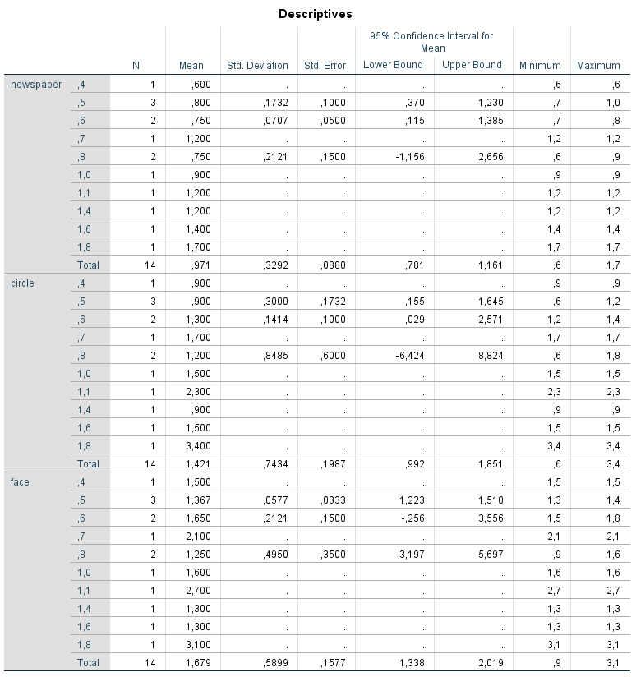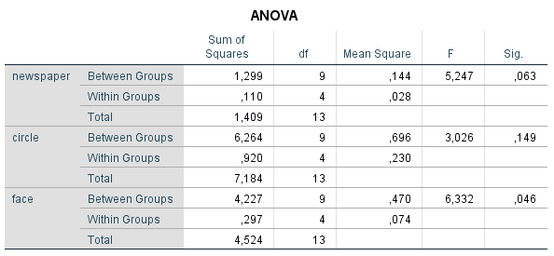

**d.**each sample is normally distributed & all pop.s have common variance & all samples independent from each other && no multicolineartiy

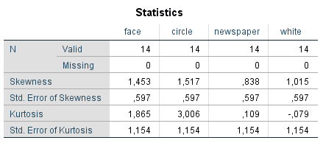skweness && kurtosis must be btw -1,+1 , newspaper & wgite paper → normal, cricle & face have some bit

**e.**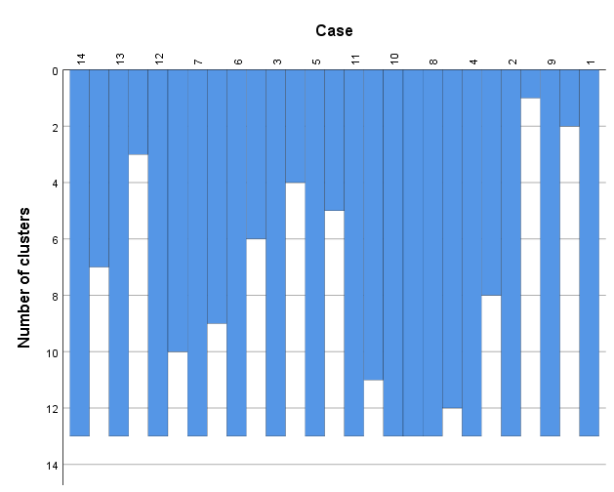

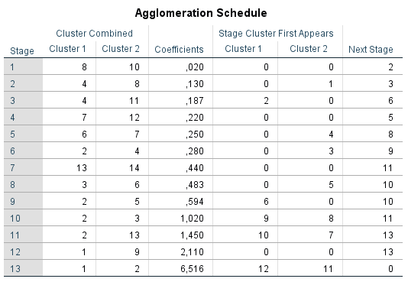deviation from normal, but not too bad.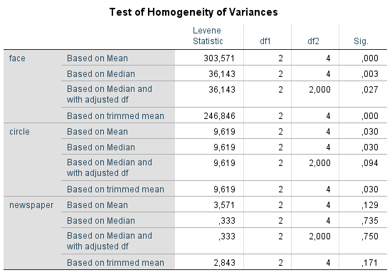

**f.**

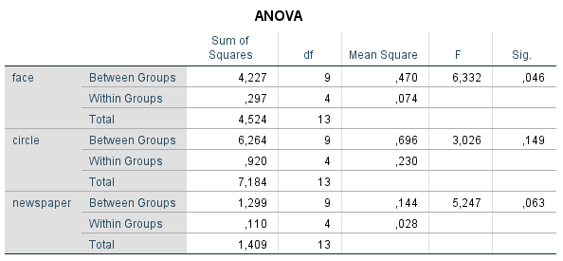p<0.05 was only with the face variable, there is no significant difference in the others, there is only the face variable.

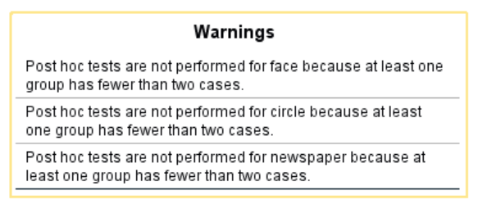

**g.** 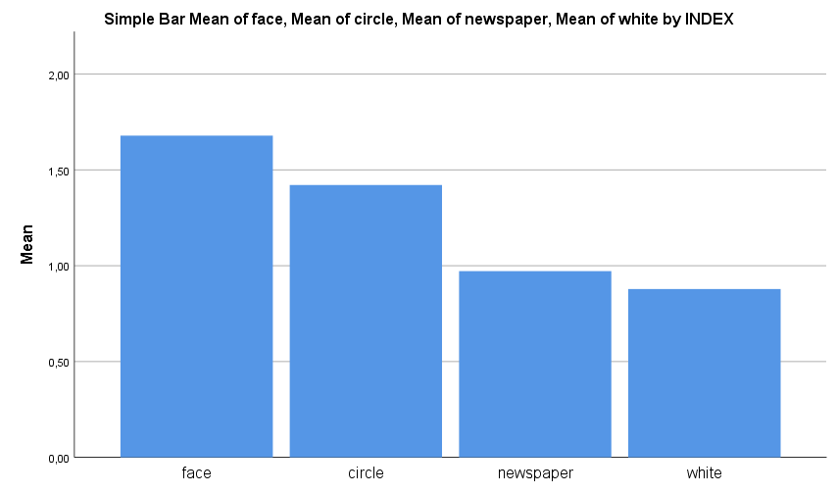

**h.** Although the face has a different gazing view, there is no serious difference between the mean in total. it is on the lowest white, although the white one is lower than all, it should be repeated with a larger data set since there is no serious difference when looking at the total.

**2.** .**a.** dependent=boys and girls differ from each other based their toy-play interactions.

**b.**two ways, mixed anova, there are 2 categorical variables (boys && girls) && one // more independent var.s uses different participants (different ages for the kids)

c.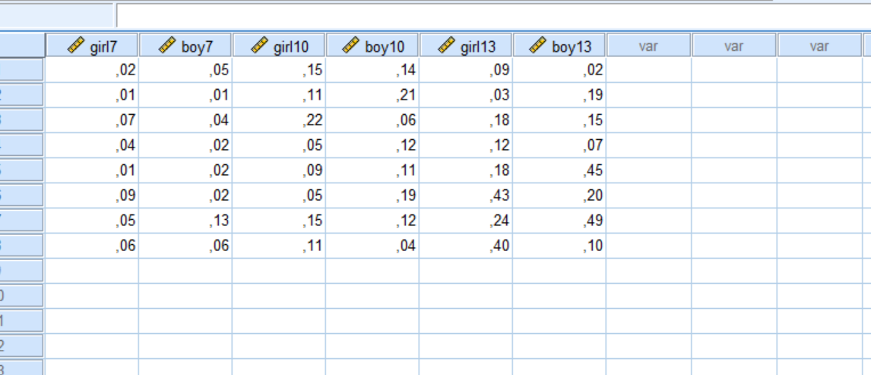

**d.**

**3. :** independents**:** Statistics, Experimental Psychology, Social Psychology, Developmental Psychology and Psychiatry: dependent, dependent: the year of the student

**assumptions:** the dependent var.s are multivariately normally distibuted for each population , with the different pop.s being defined by the levels of the factor(1). the population variances and covariances among the dependent variables are the same across all the levels of the factor / independent var. (2) the scores on a variable for any one participants is independent from the all scores on this variable for all other participants (3).

**For assumption 1:**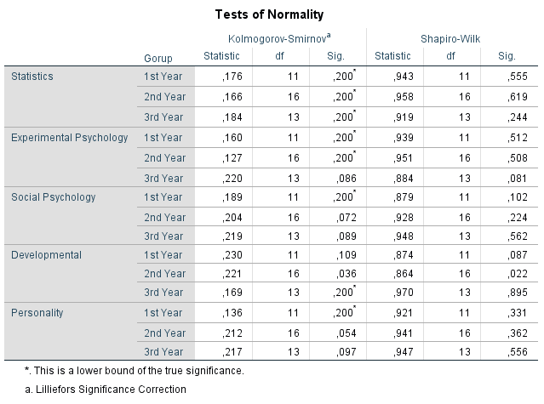

**for assumption 2 & 3: 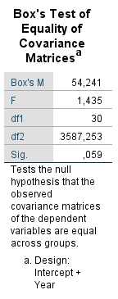not significant**

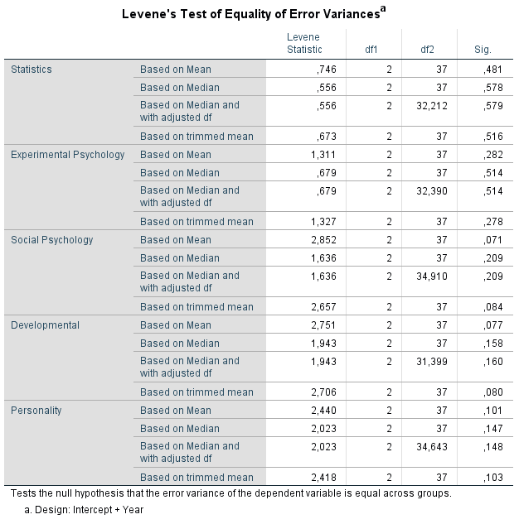

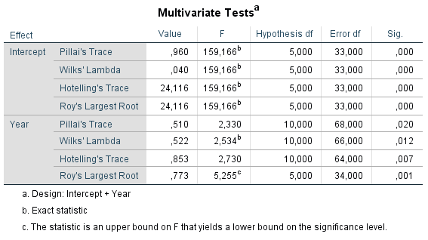

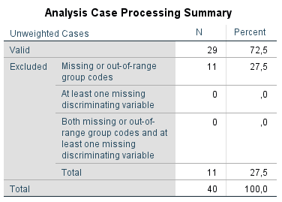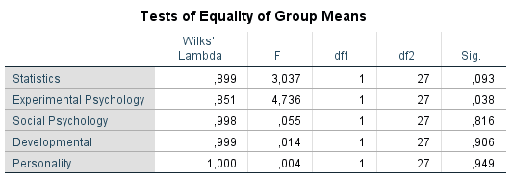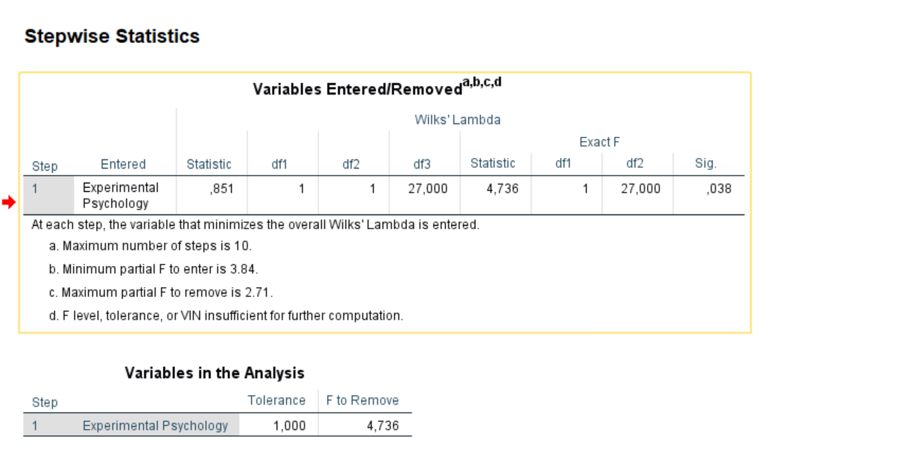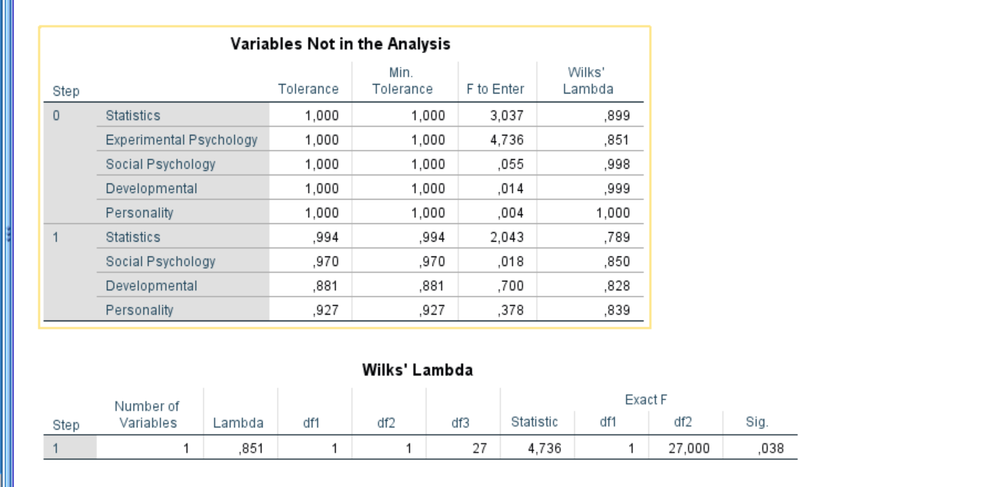

The only parameter that is effective in this with stepwise is the experimental phy. appears to be related.